ASP.NET Core Web API – Handson 1
1. Explain the Concept of RESTful Web Service, Web API & Microservice
RESTful Web Service
REST (Representational State Transfer) is an architectural style used to build web services. It allows different applications to communicate over the HTTP protocol using standard methods such as GET, POST, PUT, and DELETE. REST services are lightweight, simple, and widely used in modern web applications.
Web API
A Web API is an interface that enables communication between different software applications over HTTP. It accepts client requests, processes them, and returns the required response in formats like JSON or XML. In ASP.NET Core, Web APIs are commonly used to build backend services for web and mobile applications.
Microservice
A Microservice is a software architecture where an application is divided into small, independent services. Each service performs a specific business function and can be developed, deployed, and maintained independently.

2. Features of REST Architecture
Representational State Transfer (REST)
REST represents resources through URLs and transfers their data between the client and server.
Stateless
Every request sent by the client contains all the required information. The server does not store the client's session data.
Messages
Communication between the client and server takes place through HTTP requests and responses. The data is generally exchanged in JSON format.
Microservice Concept
Microservices divide a large application into smaller independent services, making the application easier to develop, test, and maintain.
Difference between Web Service and Web API
Web Service | Web API
Usually uses SOAP protocol | Usually uses REST architecture
Mainly supports XML | Supports JSON as well as XML
More complex | Lightweight and faster
Less flexible | More flexible and widely used
JSON Support
Unlike traditional web services, REST APIs are not restricted to XML. They can return responses in JSON, which is faster, lightweight, and easier to process.

3. Explain HTTP Request and HTTP Response
HTTP Request
An HTTP Request is sent by the client to the server to perform an operation such as retrieving, creating, updating, or deleting data.
Example:
GET /api/products
HTTP Response
An HTTP Response is sent by the server after processing the client's request. It contains the requested data along with an appropriate status code.
Example:
HTTP/1.1 200 OK

4. Types of Action Verbs
HTTP Action Verbs define the type of operation to be performed on a resource.
Action Verb | Purpose | ASP.NET Core Attribute
GET | Retrieve data | [HttpGet]
POST | Insert new data | [HttpPost]
PUT | Update existing data | [HttpPut]
DELETE | Delete data | [HttpDelete]
Example:
[HttpGet]
public IActionResult GetProducts()
{
return Ok();
}

5. HTTP Status Codes Used in Web API
Status Code | Meaning
200 OK | Request completed successfully
400 Bad Request | Client sent an invalid request
401 Unauthorized | Authentication is required or failed
500 Internal Server Error | An unexpected error occurred on the server
Example:
return Ok(data);
return BadRequest("Invalid Request");
return Unauthorized();
return StatusCode(500, "Internal Server Error");

6. Creation of a Simple Web API
A basic Web API consists of:
- Controller
- Action Methods
- HTTP Action Verbs
- Routes
Example:
[ApiController]
[Route("api/[controller]")]
public class ProductController : ControllerBase
{
[HttpGet]
public IActionResult GetProducts()
{
return Ok();
}
[HttpPost]
public IActionResult AddProduct()
{
return Ok("Product Added");
}
}
Read Operation
Uses the GET method to retrieve data.
Write Operation
Uses the POST method to insert new data.

7. Configuration Files of Web API
Program.cs / Startup.cs
Used to configure services, dependency injection, middleware, and routing. In .NET 6 and later, most configurations are handled in Program.cs.
appsettings.json
Stores application settings such as database connection strings, API keys, logging configuration, and other environment-specific values.
launchSettings.json
Defines how the application starts during development, including URLs, ports, and environment variables.
RouteConfig.cs (.NET Framework 4.5)
Used to define URL routing rules in older ASP.NET applications.
WebApiConfig.cs (.NET Framework 4.5)
Used to register Web API routes and configure Web API services in ASP.NET Framework applications.

ValuesController.cs

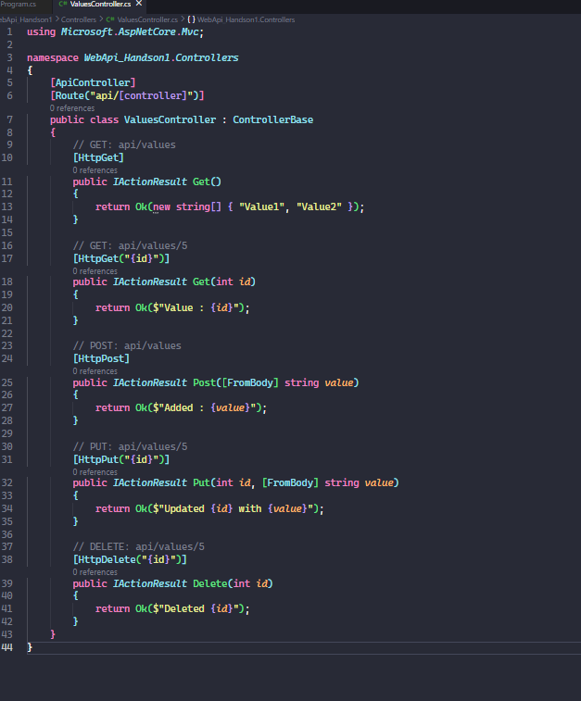
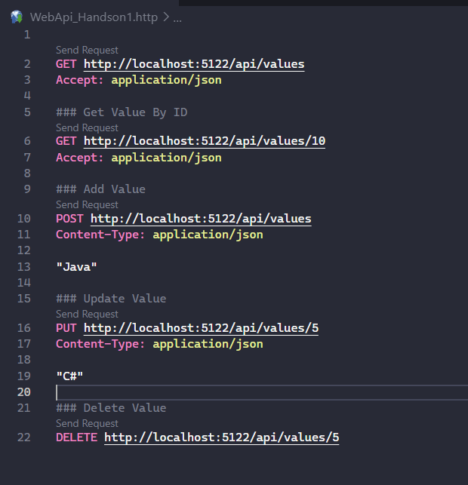
OUTPUT:



